Here’s a 7-point tabular comparison between the cloud service models: IaaS, PaaS, and SaaS.
Aspect | IaaS (Infrastructure as a Service) | PaaS (Platform as a Service) | SaaS (Software as a Service)
Service Type | Provides virtualized computing resources | Provides platform & tools to develop apps | Provides ready-to-use software over the internet
User Control Over | OS, Storage, Applications | Applications & Data | Only the usage of the software
Managed By Provider | Networking, storage, servers | Networking, storage, servers, OS, middleware | Everything (infrastructure, platform, application)
User Responsibility | Install OS, manage apps, runtime, etc. | Develop, run, and manage apps | Just use the software
Example Providers | Amazon EC2, Microsoft Azure VM, Google Compute Engine | Google App Engine, Heroku, AWS Elastic Beanstalk | Gmail, Dropbox, Salesforce, Microsoft 365
Target Users | System admins, IT professionals | Developers | End-users
Flexibility | High – full control over environment | Moderate – control over app code only | Low – user has limited configuration options

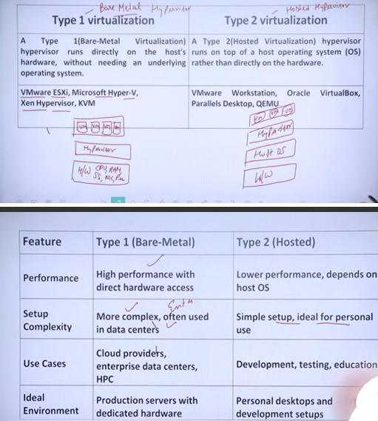

Here's a clear 8-point tabular comparison between VMware, Microsoft Hyper-V, KVM, and Xen — the major virtualization platforms:
Aspect | VMware | Microsoft Hyper-V | KVM (Kernel-based Virtual Machine) | Xen (Citrix Xen)
Type | Proprietary Type-1 & Type-2 hypervisor | Proprietary Type-1 hypervisor | Open-source Type-1 (built into Linux kernel) | Open-source Type-1 hypervisor
Developer/Owner | VMware Inc. | Microsoft | Community-driven (Red Hat, Linux Foundation) | Initially by Cambridge Univ., now under Linux Foundation
Host OS Dependency | Can run on Windows or Linux (e.g., Workstation) | Runs only on Windows OS | Integrated into Linux kernel | Separate hypervisor layer
Performance | High performance with advanced features | Good for Windows-based environments | Near-native performance on Linux | Efficient, strong isolation
Ease of Use | User-friendly GUI (vSphere, Workstation, etc.) | Easy with Windows integration | Requires command-line and Linux knowledge | Requires more setup and admin skill
Best Suited For | Enterprise-grade virtualization | Windows Server environments | Linux environments and open-source systems | Cloud platforms, research, Linux-heavy setups
Licensing | Commercial – expensive licenses | Free with Windows Server (some features paid) | Free and open-source | Free and open-source
Examples/Use Cases | vSphere, ESXi, Workstation | Windows Server, Azure Stack | Proxmox VE, Virtualization in Red Hat, Ubuntu | AWS (used Xen previously), academic projects

Here’s an 8-point tabular comparison between GFS (Google File System) and HDFS (Hadoop Distributed File System):
Aspect | GFS (Google File System) | HDFS (Hadoop Distributed File System)
Developer | Developed by Google | Developed by Apache Software Foundation
Release Year | 2003 (internal to Google) | 2006 (open-source part of Apache Hadoop project)
Source Availability | Proprietary (not open source) | Open-source
Platform Dependency | Works internally on Google’s infrastructure | Platform-independent; works on commodity hardware
Use Case | Used internally by Google to store/search massive web data | Used for big data processing by various enterprises
Programming Language | Written in C++ | Written in Java
Fault Tolerance | High fault tolerance using replication | High fault tolerance using replication (default 3 replicas)
Community Support | No public community (used only by Google) | Large global open-source community

Here’s a clear tabular comparison between Ab-initio Resource Assignment and Periodic Resource Optimization, often used in project management, operations, and resource planning contexts:
Aspect | Ab-initio Resource Assignment | Periodic Resource Optimization
Definition | Initial assignment of resources at the start of a project or process | Re-evaluation and adjustment of resources at regular intervals
Timing | Done once, usually at project initiation | Done periodically (e.g., weekly, monthly)
Objective | Allocate resources based on initial plans and estimates | Improve efficiency based on actual performance and changes
Flexibility | Less flexible – assumes stability in requirements | More flexible – adapts to changing resource needs
Data Basis | Based on forecasted workloads, assumptions, and availability | Based on real-time data, progress reports, and performance
Usage Scenario | Suitable for static or predictable environments | Suitable for dynamic or changing environments
Responsiveness to Change | Poor – not responsive to ongoing changes | High – designed to adapt and optimize regularly
Example | Assigning a set of developers at the start of a project | Reallocating developers between teams based on project workload

Aspect | OpenNebula | OpenStack
Definition | A simple and lightweight open-source cloud platform | A modular and scalable open-source cloud computing platform
Target Audience | Small to medium enterprises, private cloud setups | Large-scale enterprises, public/private/hybrid cloud providers
Complexity | Easier to install, configure, and manage | More complex with many services/modules
Architecture | Monolithic and lightweight | Modular and distributed
Use Case | Best for data centers, virtualization, and private clouds | Best for IaaS, public clouds, and large cloud environments
Resource Management | Centralized | Decentralized and more flexible
Hypervisor Support | KVM, VMware, LXD | KVM, Xen, VMware, Hyper-V, etc.
Community and Support | Smaller but focused community | Large global community with strong backing (e.g., IBM, Red Hat)

